**Hands on 1**

**Write queries on country table using Query Methods**

**Repository class:**

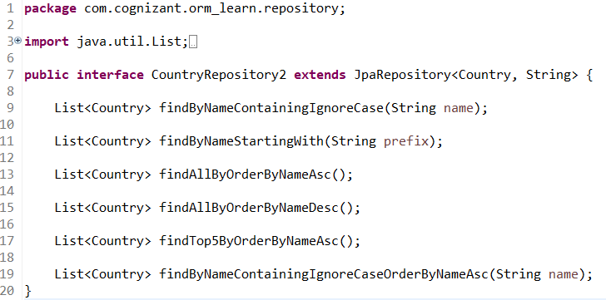

**Country.java:**

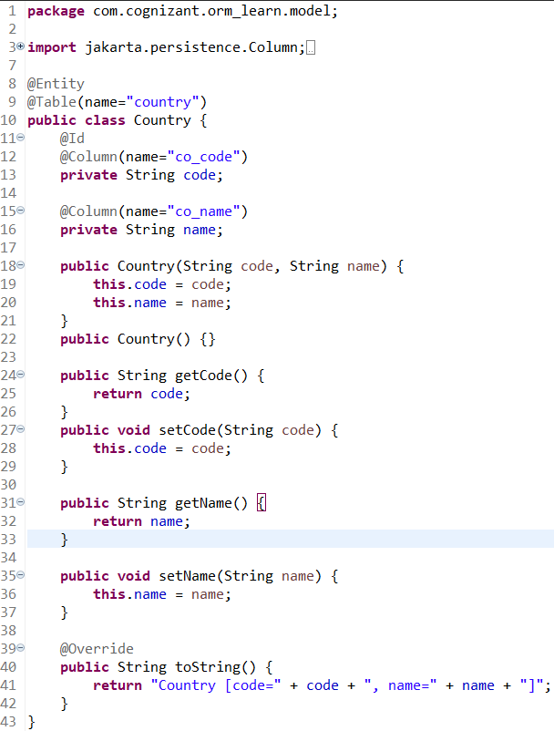

**Test Class:**

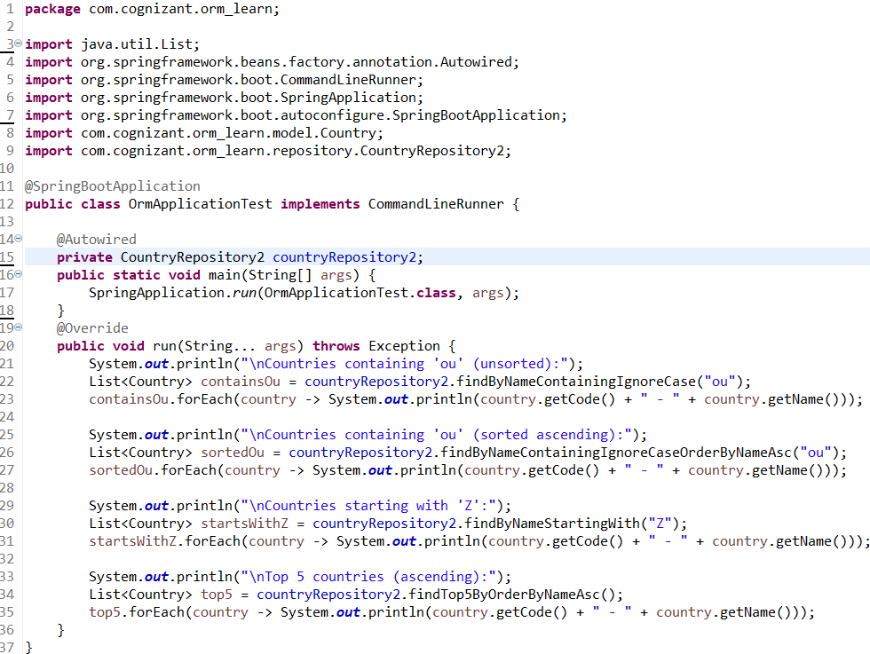

**Console Output:**

**Countries containing “ou”:**

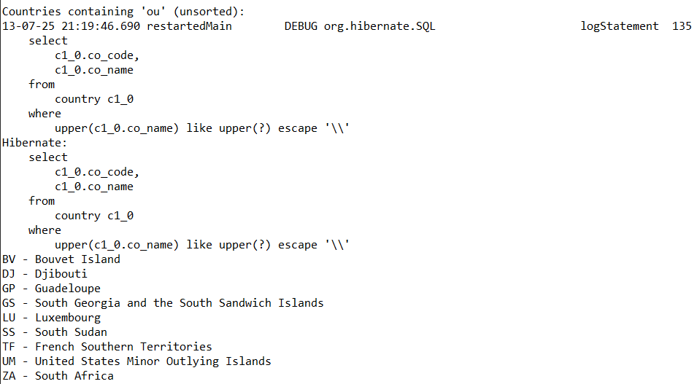

**Countries containing “ou” In ascending:**

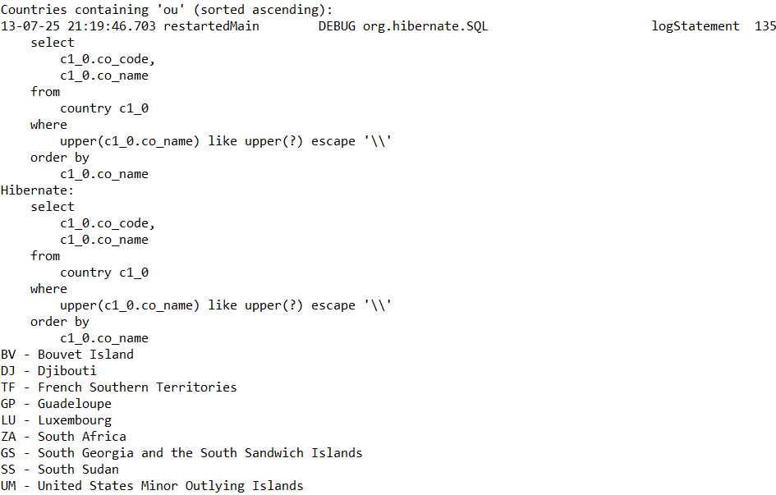

**Countries starting with letter “Z”:**

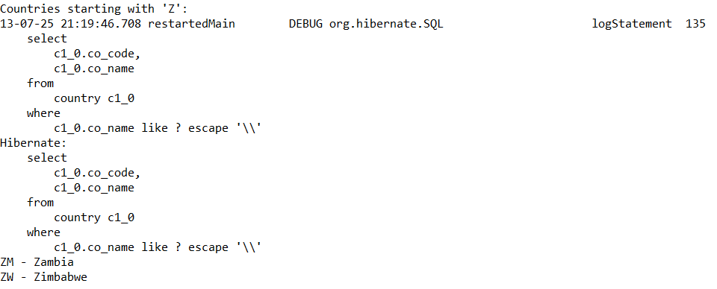

**Top 5 Countries in Ascending Order:**

